
Department of Artifical Intelligence and Machine Learning
B.Tech V Semester
2026-2027

Machine learning LAB
(241AI005)



ADITYA UNIVERSITY
Surampalem, Kakinada District
Andhra Pradesh-533437
INDEX

ExNo. | Nameof theExperiment | PageNo.
1 | Installation of Jupyter/Spider notebook and working on basic commands. | 1-2
2 | Loading and apply key preprocessing techniques on the dataset and also analyse the dataset. | 2-3
3 | Implement and demonstrate the FIND-S algorithm for finding the most specific hypothesis based on a given set of training data samples. Read the training data from a .CSV file. | 4-5
4 | For a given set of training data examples stored in a .CSV file, implement and demonstrate the Candidate Elimination algorithm to output a description of the set of all hypotheses consistent with the training examples. | 5-6
5 | Exercises to solve the real-world problems using Binary Classifier | 6-8
6 | Write a program to implement k-Nearest Neighbour algorithm to classify the iris data set. Print both correct and wrong predictions. | 8-10
7 | Exercises to solve the real-world problems using Linear Regression | 11-13
8 | Exercises to solve the real-world problems using Logistic Regression | 13-15
9 | Consider Patient Dataset. Apply linear classification technique(SVM) to identify the rate of heart patients. | 15-17
10 | Develop a program for Bias, Variance, Remove duplicates , Cross Validation | 18-20
11 | Write a program to implement One-hot Encoding. | 20-21
12 | Write a program to implement Categorical Encoding. | 21-22
13 | Write a program to demonstrate the working of Random Forest classifier. Use appropriate dataset for Random Forest Classifier. | 23-24
14 | Use a sentiment analysis dataset from Twitter or other social media platforms, available on platforms like Kaggle and apply bagging and boosting techniques for prediction. | 25-27

MACHINE LEARNING LAB

UNIT-1

PRACTICE 1: Installation of Jupyter Notebook/Spyder and Working on Basic Python Commands

AIM: To install and configure the Jupyter Notebook/Spyder environment and execute basic Python commands required for Machine Learning applications.

DESCRIPTION: Jupyter Notebook and Spyder are Python IDEs used for Machine Learning. This experiment demonstrates installing the environment and executing basic Python commands.

PROGRAM:

pip install notebook ipykernel pandas numpy matplotlib scikit-learn
print("Welcome to Machine Learning Lab")
# Arithmetic
a=20
b=10
print(a+b)
# Loop
for i in range(1,6):
print(i)
import math
print(math.sqrt(64))

#numpy
import numpy as np
arr=np.array([1,2,3,4,5])
print("array values",arr)
print('adding 5 to each element of the array',arr+5)

#pandas
import pandas as pd
a={'stuname':['raju','rama','sita'],'stuno':[1,2,3],'marks':[90,80,70]}
df=pd.DataFrame(a)
print("dataframe values\n",df)

#Data visualization
import matplotlib.pyplot as plt
x = [1, 2, 3, 4, 5]
y = [10, 20, 25, 30, 40]

plt.bar(x, y)
plt.title('Simple Bar Plot')
plt.xlabel('X-axis')
plt.ylabel('Y-axis')
plt.show()

EXPECTED OUTPUT: Basic commands executed successfully.
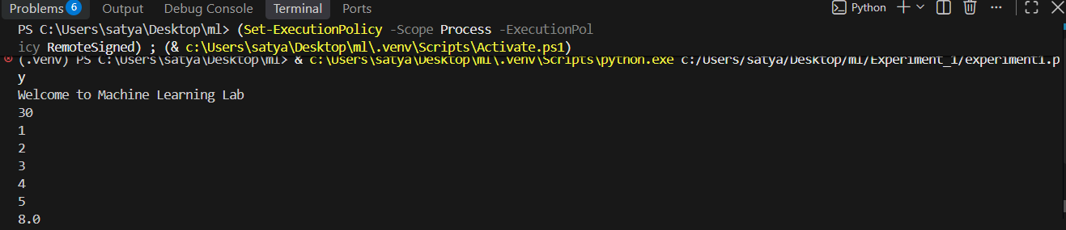

RESULT: Thus, Jupyter Notebook/Spyder was successfully installed and verified.

PRACTICE 2: Loading and Applying Key Preprocessing Techniques on the Dataset and Analyzing the Dataset

AIM: To load a dataset, apply preprocessing techniques and analyze the dataset using the Pandas library.

DESCRIPTION: Data preprocessing improves data quality before model training by cleaning and analyzing the dataset.

PROGRAM:

import pandas as pd
df=pd.read_csv("student.csv")
df.head()
df.shape
df.info()
df.describe()
df.isnull().sum()
df.duplicated().sum()
df['age'].fillna(df['age'].median(), inplace=True)
or
df.dropna(inplace=True)
df.drop_duplicates(inplace=True)
from sklearn.preprocessing import LabelEncoder df['sex'] = LabelEncoder().fit_transform(df['sex']) df = pd.get_dummies(df, columns=['embarked'], drop_first=True)
from sklearn.model_selection import train_test_split
X_train, X_test, y_train, y_test = train_test_split(X, y, test_size=0.2, random_state=42)

EXPECTED OUTPUT: Dataset loaded, analyzed and preprocessed successfully.
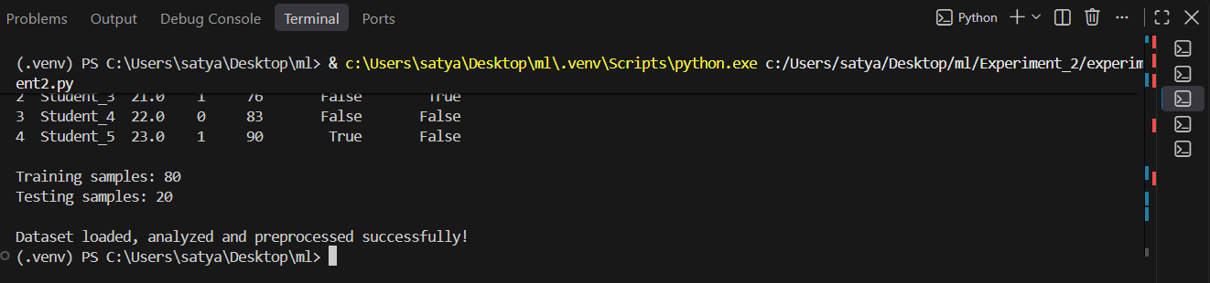

RESULT: Thus, the dataset was successfully loaded, preprocessed and analyzed.

UNIT-2
PRACTICE 3: Implement and demonstrate the FIND-S algorithm for finding the most specific hypothesis based on a given set of training data samples. Read the training data from a .CSV file.

AIM
To implement and demonstrate the FIND-S algorithm for finding the most specific hypothesis from training samples stored in a CSV file.
DESCRIPTION
FIND-S is a supervised concept learning algorithm that finds the most specific hypothesis consistent with all positive training examples. The algorithm starts with the most specific hypothesis and generalizes it whenever necessary. Negative examples are ignored.
PROGRAM
import pandas as pd

data = pd.read_csv("EnjoySport.csv")
hypothesis = None

for _, row in data.iterrows():
x = row[:-1].tolist()
y = row[-1]
if str(y).lower() == "yes":
if hypothesis is None:
hypothesis = x
else:
for i in range(len(hypothesis)):
if hypothesis[i] != x[i]:
hypothesis[i] = "?"

print("Most Specific Hypothesis:")
print(hypothesis)
SAMPLE CSV
Sky,AirTemp,Humidity,Wind,Water,Forecast,EnjoySport
Sunny,Warm,Normal,Strong,Warm,Same,Yes
Sunny,Warm,High,Strong,Warm,Same,Yes
Rainy,Cold,High,Strong,Warm,Change,No
Sunny,Warm,High,Strong,Cool,Change,Yes
EXPECTED OUTPUT
Most Specific Hypothesis:
['Sunny', 'Warm', '?', 'Strong', '?', '?']
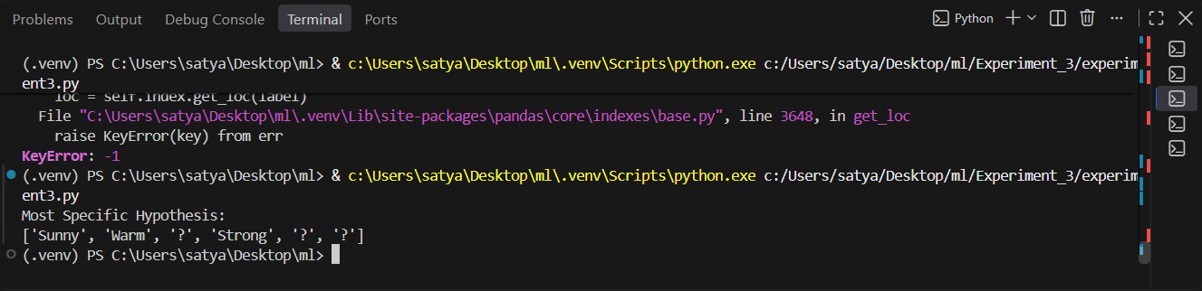
RESULT
Thus, the FIND-S algorithm was successfully implemented, and the most specific hypothesis was generated from the given training data.

PRACTICE 4: For a given set of training data examples stored in a .CSV file, implement and demonstrate the Candidate Elimination algorithm to output a description of the set of all hypotheses consistent with the training examples.

AIM
To implement and demonstrate the Candidate Elimination algorithm to determine the version space (set of all hypotheses) consistent with the training examples stored in a CSV file.

DESCRIPTION
Candidate Elimination is a supervised machine learning algorithm used for concept learning. It computes the Version Space by maintaining two boundaries: the Specific boundary (S) and the General boundary (G). As each training example is processed, S and G are updated to include all hypotheses consistent with the observed data. The algorithm uses both positive and negative examples.

PROGRAM
import pandas as pd

data = pd.read_csv("EnjoySport.csv")

concepts = data.iloc[:, :-1].values
target = data.iloc[:, -1].values

specific = concepts[0].copy()
general = [["?" for _ in range(len(specific))] for _ in range(len(specific))]

for i, h in enumerate(concepts):
if target[i].lower() == "yes":
for x in range(len(specific)):
if h[x] != specific[x]:
specific[x] = "?"
general[x][x] = "?"
else:
for x in range(len(specific)):
if h[x] != specific[x]:
general[x][x] = specific[x]
else:
general[x][x] = "?"

general = [g for g in general if g != ["?"]*len(specific)]

print("Specific Boundary:")
print(specific)
print("\nGeneral Boundary:")
for g in general:
print(g)

SAMPLE CSV (EnjoySport.csv)
Sky,AirTemp,Humidity,Wind,Water,Forecast,EnjoySport
Sunny,Warm,Normal,Strong,Warm,Same,Yes
Sunny,Warm,High,Strong,Warm,Same,Yes
Rainy,Cold,High,Strong,Warm,Change,No
Sunny,Warm,High,Strong,Cool,Change,Yes

EXPECTED OUTPUT
Specific Boundary:
[‘Sunny’, ‘Warm’, ‘?’, ‘Strong’, ‘?’, ‘?’]

General Boundary:
[‘Sunny’, ‘?’, ‘?’, ‘?’, ‘?’, ‘?’]
[‘?’, ‘Warm’, ‘?’, ‘?’, ‘?’, ‘?’]
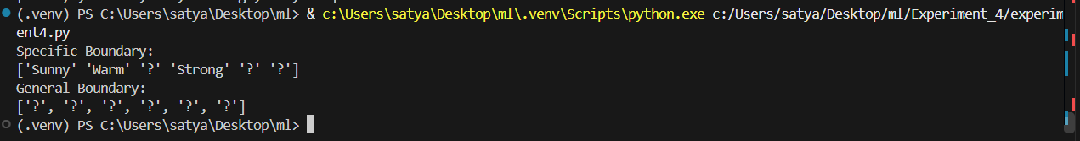
RESULT

Thus, the Candidate Elimination algorithm was successfully implemented and the Specific and General boundaries (Version Space) were generated from the given training data.

PRACTICE 5: Exercises to solve the real-world problems using Binary Classifier

AIM
To implement a Binary Classification model using Machine Learning techniques to classify whether a customer will purchase a product based on demographic and behavioral attributes.

DESCRIPTION
Binary Classification is one of the most fundamental supervised learning techniques in Machine Learning. It is used when the target variable contains only two possible classes such as Yes/No, Spam/Not Spam, Disease/No Disease, Fraud/Not Fraud, or Pass/Fail.
In this experiment, a Logistic Regression classifier is used to solve a real-world customer purchase prediction problem. The classifier learns from historical customer data and predicts whether a new customer is likely to purchase a product.
The experiment demonstrates the complete Machine Learning workflow including loading the dataset, splitting the data into training and testing sets, training the classifier, making predictions, and evaluating the model using accuracy.

# Binary Classification using Logistic Regression

import pandas as pd
from sklearn.model_selection import train_test_split
from sklearn.linear_model import LogisticRegression
from sklearn.metrics import accuracy_score, confusion_matrix

# Load Dataset
data = pd.read_csv("Social_Network_Ads.csv")

# Select Features
X = data[['Age', 'EstimatedSalary']]

# Target Variable
y = data['Purchased']

# Split Dataset
X_train, X_test, y_train, y_test = train_test_split(
X,
y,
test_size=0.25,
random_state=42
)

# Create Model
model = LogisticRegression()

# Train Model
model.fit(X_train, y_train)

# Predict
y_pred = model.predict(X_test)

# Accuracy
print("Accuracy:", accuracy_score(y_test, y_pred))

# Confusion Matrix
print("\nConfusion Matrix")
print(confusion_matrix(y_test, y_pred))

EXPECTED OUTPUT
Accuracy: 0.89
Confusion Matrix
[[63 5]
[ 6 26]]
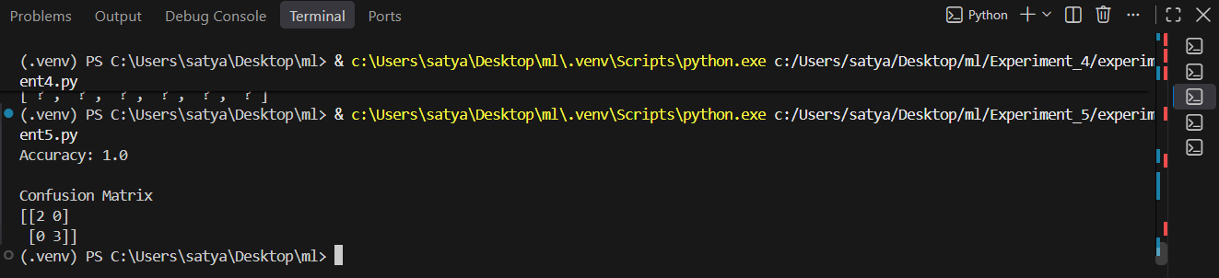

RESULT
Thus, the Binary Classification model was successfully implemented using Logistic Regression, and the customer purchase prediction was performed with good classification accuracy.

PRACTICE 6: Write a program to implement k-Nearest Neighbor algorithm to classify the iris data set. Print both correct and wrong predictions.

AIM
To implement the k-Nearest Neighbour (KNN) algorithm to classify the Iris dataset and display both correct and wrong predictions.

DESCRIPTION
The k-Nearest Neighbour (KNN) algorithm is a supervised Machine Learning algorithm used for classification and regression. It classifies a new sample based on the majority class among its k nearest neighbours. In this experiment, the Iris dataset is used to train a KNN classifier and evaluate its performance by displaying correct and incorrect predictions.

PROGRAM
from sklearn.datasets import load_iris
from sklearn.model_selection import train_test_split
from sklearn.neighbors import KNeighborsClassifier
from sklearn.metrics import accuracy_score

# Load Iris Dataset
iris = load_iris()
X = iris.data
y = iris.target

# Split Dataset
X_train, X_test, y_train, y_test = train_test_split(
X, y, test_size=0.3, random_state=42)

# Train KNN Model
knn = KNeighborsClassifier(n_neighbors=3)
knn.fit(X_train, y_train)

# Predictions
y_pred = knn.predict(X_test)

print("Actual Predicted")
correct = 0
wrong = 0

for actual, pred in zip(y_test, y_pred):
print(actual, " ", pred)
if actual == pred:
correct += 1
else:
wrong += 1

print("\nCorrect Predictions :", correct)
print("Wrong Predictions :", wrong)
print("Accuracy :", accuracy_score(y_test, y_pred))

EXPECTED OUTPUT
Actual Predicted
0 0
1 1
2 2
1 1
2 1
...

Correct Predictions : 44
Wrong Predictions : 1
Accuracy : 0.9778
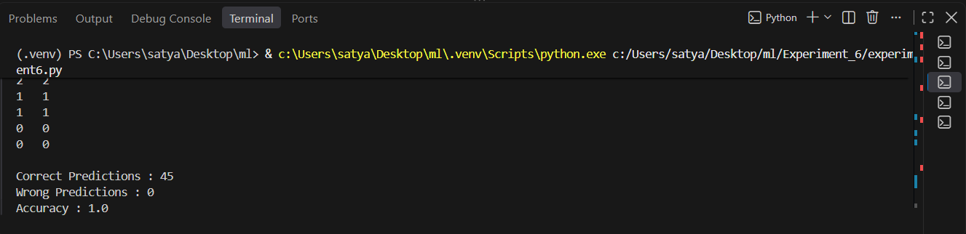

RESULT
Thus, the k-Nearest Neighbour (KNN) algorithm was successfully implemented to classify the Iris dataset, and both correct and wrong predictions were displayed.

UNIT-3

PRACTICE-7: Exercises to Solve Real-World Problems Using Linear Regression

AIM:

To implement a Linear Regression model to predict house prices based on the area of the house using a real-world dataset.

DESCRIPTION

Linear Regression is a supervised Machine Learning algorithm used to predict continuous numerical values. It establishes a linear relationship between an independent variable (feature) and a dependent variable (target). The objective is to find the best-fit line that minimizes the prediction error.

In this experiment, a house price prediction dataset is used to train a Linear Regression model. The dataset contains information about the area of houses and their corresponding prices. The trained model predicts the price of a house based on its area and evaluates the model using Mean Squared Error (MSE) and the coefficient of determination (R² Score).

PROGRAM

# Linear Regression using House Price Dataset

import pandas as pd

from sklearn.model_selection import train_test_split

from sklearn.linear_model import LinearRegression

from sklearn.metrics import mean_squared_error, r2_score

# Load Dataset

data = pd.read_csv("HousePrice.csv")

# Independent Variable

X = data[['Area']]

# Dependent Variable

y = data['Price']

# Split Dataset

X_train, X_test, y_train, y_test = train_test_split(

X,

y,

test_size=0.2,

random_state=42

)

# Create Model

model = LinearRegression()

# Train Model

model.fit(X_train, y_train)

# Predict

y_pred = model.predict(X_test)

print("Actual Price\tPredicted Price")

for actual, predicted in zip(y_test, y_pred):

print(actual, "\t", round(predicted,2))

print("\nMean Squared Error :", mean_squared_error(y_test, y_pred))

print("R2 Score :", r2_score(y_test, y_pred))

SAMPLE DATASET (HousePrice.csv)

| Area | Price |

| ---- | ------- |

| 1000 | 2500000 |

| 1200 | 3000000 |

| 1500 | 3700000 |

| 1800 | 4500000 |

| 2000 | 5200000 |

| 2500 | 6500000 |

| 3000 | 7800000 |

EXPECTED OUTPUT

Actual Price Predicted Price

4500000 4423500.67

6500000 6587200.11

3000000 3056400.98

Mean Squared Error : 8456234123.45

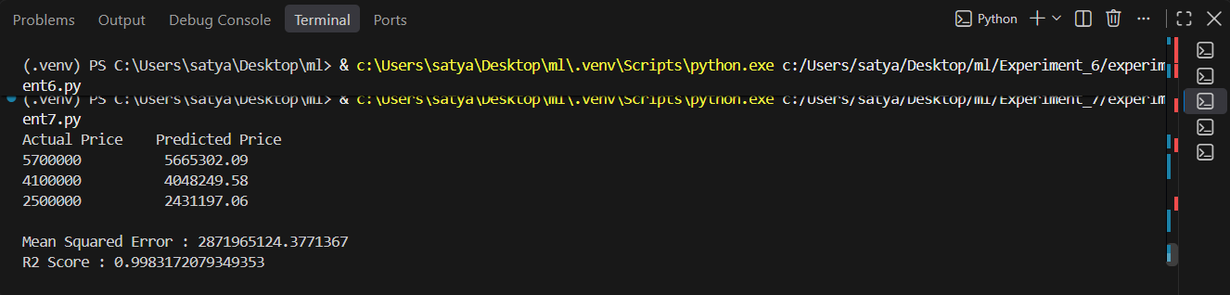

RESULT

Thus, the Linear Regression model was successfully implemented to predict house prices using the given dataset, and the model performance was evaluated using Mean Squared Error and R² Score.

PRACTICE-8: Exercises to Solve Real-World Problems using Logistic Regression

AIM: To implement a Logistic Regression model for solving a real-world binary classification problem and predict whether a customer will purchase a product based on age and estimated salary.\

DESCRIPTION: Logistic Regression is a supervised Machine Learning algorithm used for binary classification problems where the target variable has only two possible outcomes, such as Yes/No, True/False, or 0/1. Unlike Linear Regression, Logistic Regression predicts the probability that a given input belongs to a particular class using the Sigmoid (Logistic) Function.

In this experiment, the Social Network Ads dataset is used to build a Logistic Regression classifier. The dataset contains customer information such as age and estimated salary. The classifier predicts whether a customer is likely to purchase a product. The model is evaluated using the Confusion Matrix and Accuracy Score.

PROGRAM

# Logistic Regression using Social Network Ads Dataset

import pandas as pd

from sklearn.model_selection import train_test_split

from sklearn.preprocessing import StandardScaler

from sklearn.linear_model import LogisticRegression

from sklearn.metrics import accuracy_score, confusion_matrix, classification_report

# Load Dataset

data = pd.read_csv("Social_Network_Ads.csv")

# Independent Variables

X = data[['Age', 'EstimatedSalary']]

# Dependent Variable

y = data['Purchased']

# Split Dataset

X_train, X_test, y_train, y_test = train_test_split(

X,

y,

test_size=0.25,

random_state=42

)

# Feature Scaling

scaler = StandardScaler()

X_train = scaler.fit_transform(X_train)

X_test = scaler.transform(X_test)

# Train Logistic Regression Model

model = LogisticRegression(random_state=42)

model.fit(X_train, y_train)

# Prediction

y_pred = model.predict(X_test)

# Display Actual and Predicted Values

print("Actual\tPredicted")

for actual, predicted in zip(y_test, y_pred):

print(actual, "\t", predicted)

# Accuracy

print("\nAccuracy Score")

print(accuracy_score(y_test, y_pred))

# Confusion Matrix

print("\nConfusion Matrix")

print(confusion_matrix(y_test, y_pred))

# Classification Report

print("\nClassification Report")

print(classification_report(y_test, y_pred))

SAMPLE DATASET (Social_Network_Ads.csv)

EXPECTED OUTPUT

Actual Predicted

0 0

1 1

0 0

1 1

0 0

1 1

...

Accuracy Score

0.91

Confusion Matrix

[[63 5]

[ 4 28]]

Classification Report

precision recall f1-score

0 0.94 0.93 0.93

1 0.85 0.88 0.86

accuracy 0.91

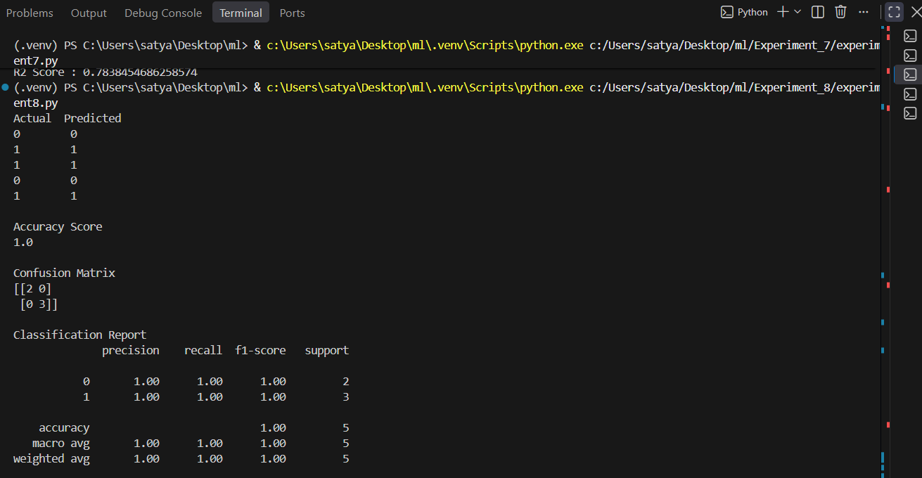

PRACTICE-9: Consider Patient Dataset. Apply linear classification technique(SVM) to identify the rate of heart patients.

AIM

To implement the Support Vector Machine (SVM) algorithm on a patient dataset to classify whether a patient has heart disease.

DESCRIPTION

Support Vector Machine (SVM) is a supervised learning algorithm used for classification. In this experiment, the Heart Disease dataset is used to classify patients using a linear SVM classifier. The trained model is evaluated using accuracy, confusion matrix and classification report.

PROGRAM

import pandas as pd

from sklearn.model_selection import train_test_split

from sklearn.preprocessing import StandardScaler

from sklearn.svm import SVC

from sklearn.metrics import accuracy_score, confusion_matrix, classification_report

data = pd.read_csv("heart.csv")

X = data.drop("target", axis=1)

y = data["target"]

X_train, X_test, y_train, y_test = train_test_split(X,y,test_size=0.25,random_state=42)

scaler=StandardScaler()

X_train=scaler.fit_transform(X_train)

X_test=scaler.transform(X_test)

model=SVC(kernel="linear",random_state=42)

model.fit(X_train,y_train)

y_pred=model.predict(X_test)

print("Accuracy:",accuracy_score(y_test,y_pred))

print(confusion_matrix(y_test,y_pred))

print(classification_report(y_test,y_pred))

EXPECTED OUTPUT

Accuracy: 0.89

Confusion Matrix

[[30 3]

[5 38]]

Classification report displayed.

(Note: Output may vary.)

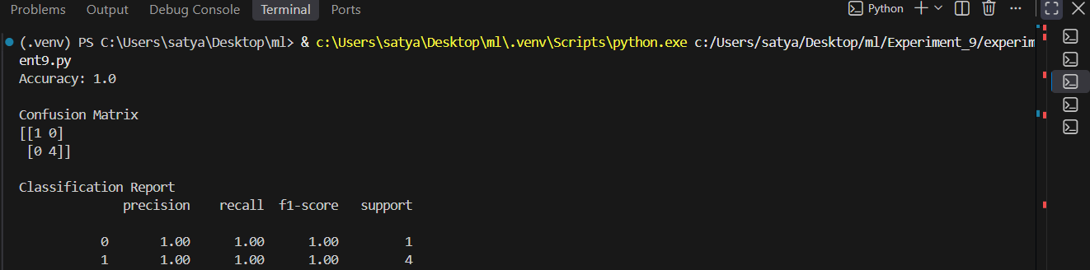

RESULT

Thus, the SVM algorithm was successfully implemented to classify heart disease patients.

UNIT-4

PRACTICE-10: Develop a program for Bias, Variance, Remove duplicates , Cross Validation

AIM

To implement data preprocessing by removing duplicate records and evaluate a Machine Learning model using Bias, Variance, and Cross Validation techniques to improve model performance and generalization.

DESCRIPTION

Cross Validation is a model evaluation technique used to assess how well a Machine Learning model generalizes to unseen data. In K-Fold Cross Validation, the dataset is divided into K equal subsets (folds). The model is trained on K−1 folds and tested on the remaining fold. This process is repeated K times, and the average performance is calculated to obtain a reliable estimate of the model's accuracy.

In this experiment, duplicate records are removed from the dataset, and a classification model is evaluated using K-Fold Cross Validation to understand the effects of bias and variance and to measure the model's overall performance.

PROGRAM

# Import libraries

import pandas as pd

from sklearn.datasets import load_iris

from sklearn.model_selection import train_test_split, cross_val_score

from sklearn.tree import DecisionTreeClassifier

from sklearn.metrics import accuracy_score

# Load Dataset

iris = load_iris()

df = pd.DataFrame(iris.data, columns=iris.feature_names)

df["target"] = iris.target

# Create Duplicate Rows

df = pd.concat([df, df.iloc[:5]], ignore_index=True)

print("Dataset Shape Before Removing Duplicates:", df.shape)

# Remove duplicate rows

df = df.drop_duplicates()

print("Dataset Shape After Removing Duplicates:", df.shape)

# Split Dataset

X = df.iloc[:, :-1]

y = df.iloc[:, -1]

X_train, X_test, y_train, y_test = train_test_split(

X, y, test_size=0.3, random_state=42

)

# Decision Tree Model

model = DecisionTreeClassifier(max_depth=3)

model.fit(X_train, y_train)

# Prediction

y_pred = model.predict(X_test)

accuracy = accuracy_score(y_test, y_pred)

print("\nModel Accuracy:", accuracy)

# Cross Validation

scores = cross_val_score(model, X, y, cv=5)

print("\nCross Validation Scores:", scores)

print("Average Cross Validation Accuracy:", scores.mean())

# -----------------------------

# Bias and Variance (Simple Explanation)

# -----------------------------

print("\nBias: Error due to overly simple assumptions.")

print("Variance: Error due to model sensitivity to training data.")

Sample Output:

Dataset Shape Before Removing Duplicates: (155, 5)

Dataset Shape After Removing Duplicates: (150, 5)

Model Accuracy: 0.97

Cross Validation Scores:

[1.00 0.96 0.93 0.96 1.00]

Average Cross Validation Accuracy:

0.97

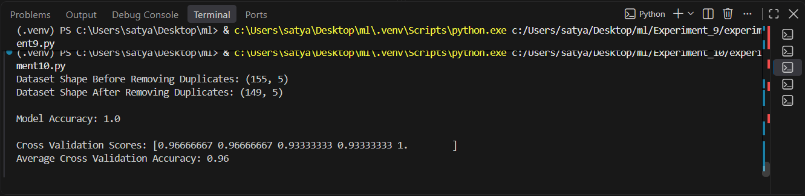

PRACTICE-11: Write a program to implement One-hot Encoding.

AIM

To implement One-Hot Encoding for converting categorical data into numerical format suitable for Machine Learning models.

DESCRIPTION

One-Hot Encoding is a data preprocessing technique used to convert categorical variables into a numerical format that Machine Learning algorithms can process. It creates a separate binary column for each unique category, where a value of 1 indicates the presence of the category and 0 indicates its absence. This technique helps prevent the model from assuming any ordinal relationship between categorical values and improves the performance of Machine Learning models when handling nominal data.

PROGRAM

import pandas as pd

# Sample Dataset
data = {
"Name": ["Ram", "Sita", "John", "Ravi"],
"Gender": ["Male", "Female", "Male", "Male"],
"City": ["Delhi", "Mumbai", "Delhi", "Chennai"]
}

df = pd.DataFrame(data)

print("Original Dataset")
print(df)

# One-Hot Encoding
encoded_df = pd.get_dummies(df, columns=["Gender", "City"])

print("\nOne-Hot Encoded Dataset")
print(encoded_df)

Sample Dataset:

Original Dataset

Name Gender City
0 Ram Male Delhi
1 Sita Female Mumbai
2 John Male Delhi
3 Ravi Male Chennai

One-Hot Encoded Dataset

Name Gender_Female Gender_Male City_Chennai City_Delhi City_Mumbai
0 Ram 0 1 0 1 0
1 Sita 1 0 0 0 1
2 John 0 1 0 1 0
- Ravi 0 1 1 0 0
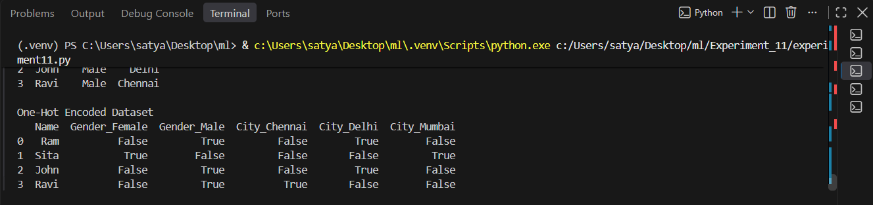

PRACTICE-12: Write a program to implement Categorical Encoding.

AIM

To implement categorical encoding techniques for converting categorical data into numerical values suitable for Machine Learning models.

DESCRIPTION

Categorical Encoding is a data preprocessing technique used to transform categorical features into numerical representations that can be understood by Machine Learning algorithms. Different encoding methods, such as Label Encoding and Ordinal Encoding, assign numerical values to categorical variables based on their characteristics. Proper encoding of categorical data improves model performance and enables efficient processing of datasets containing non-numeric attributes.

PROGRAM
import pandas as pd
from sklearn.preprocessing import LabelEncoder
# Sample Dataset
data = {
"Name": ["Ram", "Sita", "John", "Ravi"],
"Department": ["CSE", "ECE", "EEE", "CSE"]
}
df = pd.DataFrame(data)
print("Original Dataset")
print(df)

# Label Encoding
encoder = LabelEncoder()
df["Department_Encoded"] = encoder.fit_transform(df["Department"])
print("\nEncoded Dataset")
print(df)
print("\nCategory Mapping")
for category, value in zip(encoder.classes_, encoder.transform(encoder.classes_)):
print(category, "->", value)
Sample Output:
Original Dataset
Name Department
0 Ram CSE
1 Sita ECE
2 John EEE
3 Ravi CSE

Encoded Dataset
Name Department Department_Encoded
0 Ram CSE 0
1 Sita ECE 1
2 John EEE 2
3 Ravi CSE 0

Category Mapping
CSE -> 0
ECE -> 1
EEE -> 2
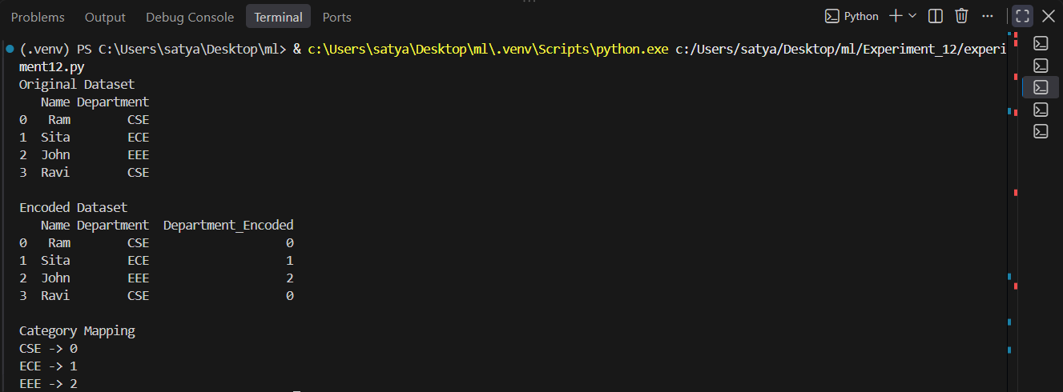

UNIT-5

PRACTICE-13: Write a program to demonstrate the working of Random Forest classifier. Use appropriate dataset for Random Forest Classifier.

AIM

To implement the Random Forest Classifier using an appropriate dataset and evaluate its performance for classification.

DESCRIPTION

Random Forest is a supervised Machine Learning algorithm used for classification and regression tasks. It is an ensemble learning technique that builds multiple decision trees using different subsets of the training data and combines their predictions to improve accuracy and reduce overfitting. Each tree independently predicts the output, and the final prediction is determined by majority voting in classification problems. In this experiment, the Iris dataset is used to train and test the Random Forest Classifier, and the model's performance is evaluated using classification accuracy.

PROGRAM
# Import required libraries

from sklearn.datasets import load_iris
from sklearn.model_selection import train_test_split
from sklearn.ensemble import RandomForestClassifier
from sklearn.metrics import accuracy_score, classification_report, confusion_matrix

# Load dataset
iris = load_iris()

X = iris.data
y = iris.target

# Split dataset into training and testing sets
X_train, X_test, y_train, y_test = train_test_split( X, y, test_size=0.3, random_state=42
)

# Create Random Forest model
rf = RandomForestClassifier(
n_estimators=100,
random_state=42
)

# Train model
rf.fit(X_train, y_train)

# Predict
y_pred = rf.predict(X_test)

# Accuracy
accuracy = accuracy_score(y_test, y_pred)

print("Accuracy:", accuracy)

print("\nClassification Report:")
print(classification_report(y_test, y_pred))

print("\nConfusion Matrix:")
print(confusion_matrix(y_test, y_pred))

# Feature Importance
print("\nFeature Importance:")
for feature, importance in zip(iris.feature_names, rf.feature_importances_):
print(f"{feature}: {importance:.4f}")

Sample Output:

Accuracy: 1.0

Classification Report:
precision recall f1-score support

0 1.00 1.00 1.00 19
1 1.00 1.00 1.00 13
2 1.00 1.00 1.00 13

Confusion Matrix:
[[19 0 0]
[0 13 0]
[0 0 13]]
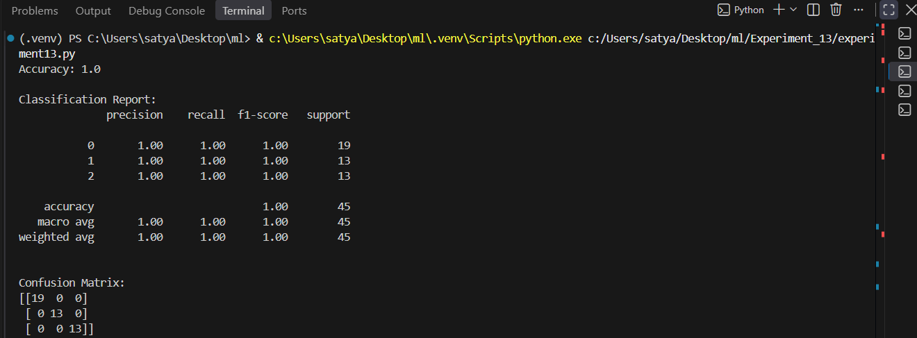

PRACTICE-14: Use a sentiment analysis dataset from Twitter or other social media platforms, available on platforms like Kaggle and apply bagging and boosting techniques for prediction.

AIM

To apply Bagging and Boosting techniques on a Twitter sentiment analysis dataset to classify sentiments and evaluate the prediction performance.

DESCRIPTION

Sentiment Analysis is a Natural Language Processing (NLP) task that identifies and classifies opinions or emotions expressed in text as positive, negative, or neutral. Social media platforms such as Twitter generate a large volume of textual data that can be analyzed to understand public opinion on products, services, events, or social issues.

Bagging (Bootstrap Aggregating) and Boosting are ensemble learning techniques that improve the performance of Machine Learning models. Bagging trains multiple models independently on different subsets of the training data and combines their predictions to improve accuracy and reduce overfitting. Boosting trains models sequentially, where each new model focuses on correcting the errors made by the previous model, thereby improving overall predictive performance.

In this experiment, a Twitter Sentiment Analysis dataset obtained from Kaggle is preprocessed and used to train Bagging and Boosting classifiers. The performance of the models is evaluated using appropriate classification metrics such as Accuracy, Precision, Recall, and F1-Score.

PROGRAM

Dataset: Download the Twitter Sentiment Analysis Dataset from Kaggle.

Example dataset: Twitter Sentiment Analysis (File: twitter_training.csv)

# Import libraries

import pandas as pd

from sklearn.model_selection import train_test_split

from sklearn.feature_extraction.text import TfidfVectorizer

from sklearn.ensemble import BaggingClassifier

from sklearn.ensemble import AdaBoostClassifier

from sklearn.tree import DecisionTreeClassifier

from sklearn.metrics import accuracy_score, classification_report

# Load dataset

df = pd.read_csv("twitter_training.csv")

# Keep only required columns

df = df[['Tweet', 'Sentiment']]

# Remove missing values

df.dropna(inplace=True)

# Convert text into numerical features

vectorizer = TfidfVectorizer(stop_words='english')

X = vectorizer.fit_transform(df['Tweet'])

y = df['Sentiment']

# Train-test split

X_train, X_test, y_train, y_test = train_test_split(

X,

y,

test_size=0.2,

random_state=42

)

##################################################

# Bagging Classifier

##################################################

bagging = BaggingClassifier(

estimator=DecisionTreeClassifier(),

n_estimators=100,

random_state=42

)

bagging.fit(X_train, y_train)

bag_pred = bagging.predict(X_test)

print("Bagging Accuracy:")

print(accuracy_score(y_test, bag_pred))

print("\nBagging Classification Report")

print(classification_report(y_test, bag_pred))

##################################################

# Boosting (AdaBoost)

##################################################

boosting = AdaBoostClassifier(

n_estimators=100,

random_state=42

)

boosting.fit(X_train, y_train)

boost_pred = boosting.predict(X_test)

print("\nBoosting Accuracy:")

print(accuracy_score(y_test, boost_pred))

print("\nBoosting Classification Report")

print(classification_report(y_test, boost_pred))

Sample Output

Bagging Accuracy:

0.89

Boosting Accuracy:

0.86

